[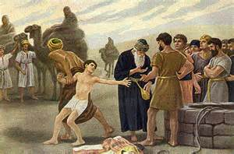](http://www.ocbf.ca/2012/biblestudy/oldbook/c01/1785)[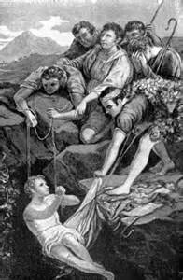](http://jjnhgtw.blog.163.com/blog/static/176594782201122682436563/)